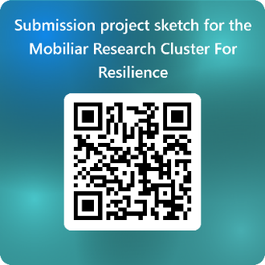
This document serves as a template for submitting the project sketch for the 2025 project call of the Mobiliar Research Cluster For Resilience. Please feel free to customize it to suit your needs but ensure that the key elements outlined in this template are included in your submission. Your sketch will be reviewed by the members of the steering committee (STC) of the research cluster. The STC will invite applicants to develop a full proposal in July 2025. Please delete the instructional text before submitting your sketch. If you have any questions, please do not hesitate to reach out to steve.heinke@unifr.ch . Please submit the document in French, German, or preferably English, by June 15th, 2025, as pdf here: https://forms.office.com/e/RdUk3uEbKV

- New Projects
Please provide a project sketch of no more than two pages, outlining the following:
- What is the background of the project, and which research gap does it address?
- What is your approach to tackling this issue?
- Why and how is a trans- and interdisciplinary perspective particularly suited to addressing this problem?
- What are the expected societal and/or economic benefits of your project?
- How will the project contribute to UniFR and the involved research groups?
- How do you plan to contribute to the activities of the research cluster?
- Which researchers are involved, and what are their roles (e.g., Lead PIs, Co-Leads, Contributors)?
- Existing Projects seeking extension
Please provide a project sketch of no more than three pages, incorporating all aspects mentioned in Section 1 and additionally addressing the following:
- Summarize your project's key accomplishments
- How did you contribute to the activities and overall success of the research cluster
- Any planned changes in the researchers involved
- Describe concrete outcomes and practical solutions that will enhance the resilience of Swiss society or the economy, resulting from an extension of your project
- Projects initiated by post-doctoral researchers
Please provide a project sketch of no more than three pages, incorporating all aspects mentioned in Section 1 and additionally addressing the following:
- Describe the role of the supporting professors and include a signed statement from each (not counting toward the page limit). Who will be your main reference person from a different field than your PhD?
- How will you interact with them and their teams, and how will this benefit your research and career?
- Describe in your own words 1-3 of your major achievements with selected works across your entire career.
- How does this project benefit you in your academic career?
- The submission form can only be accessed by members of the University of Fribourg. If you are external at the time of submission, please ask your main sponsor to upload the documents on your behalf.

